**Lab Test**

;<Author> : Nitin

;Date - 29.04.2022

;Description - Test

jmp start

;data

;code

start: nop

lxi h,0016h

mov a,m

inx h

add m

inx h

mov m,a

lxi h,0016h

mov a,m

inx h

sub m

inx h

inx h

mov m,a

lxi h,0018h

mov a,m

lxi h,0019h

mov b,m

add b

sta 001Ah

hlt

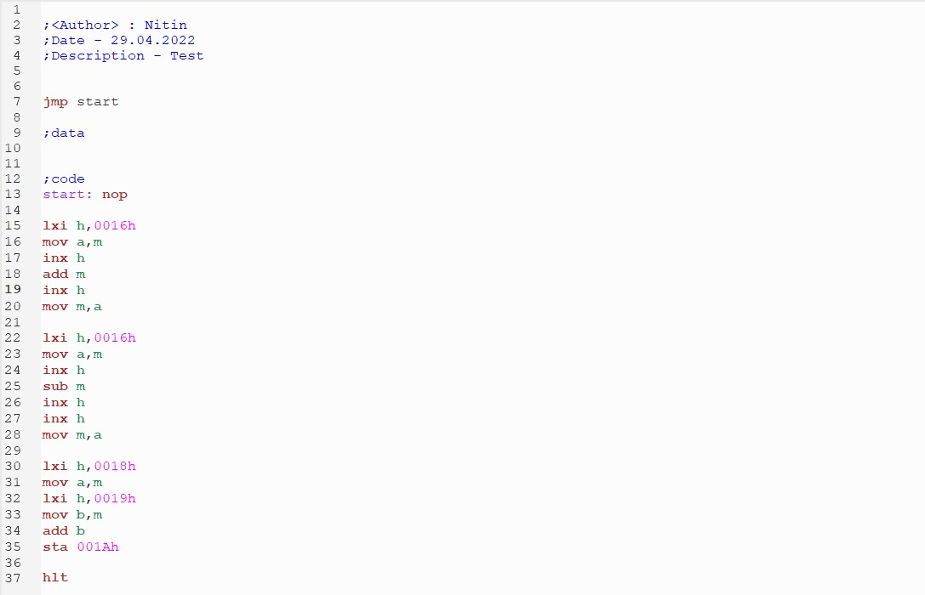

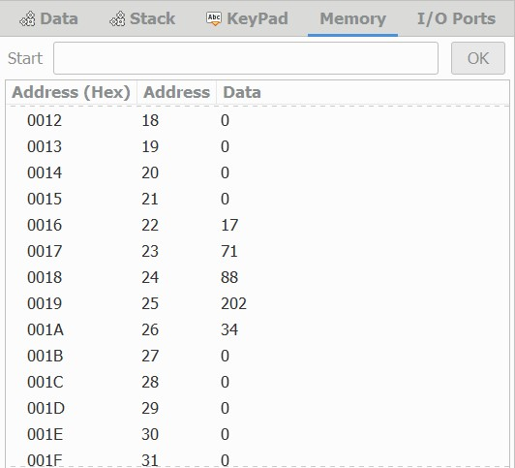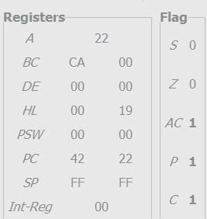

**Explaination**

17 + 71 is equal to 88.

17 – 71 is equal to -54 and 256 -54 is 202.

88 – 54 is equal to 34.